**D.Y. PATIL COLLEGE OF ENGINEERING & TECHNOLOGY, KOLHAPUR**

**(An Autonomous Institute)**



**DEPARTMENT OF CSE (DATA SCIENCE)**

A

Synopsis Report

on

**“Proactive IT Support System”**

Submitted by

|  |  |
| --- | --- |
| **Name** | **Roll No.** |
| Mr. Tejas Vaibhav Kevate | 11 |
| Mr. Afif Sharif Sayyad | 13 |
| Mr. Amey Uday Yarnalkar | 15 |
| Mr. Basavraj Sawanta Mali | 67 |

**Under the guidance of**

**Mr. S. K. Patil**

**Final Year B. Tech. CSE (Data Science)**

**Academic Year 2024-25**

**INDEX**

|  |  |  |
| --- | --- | --- |
| **Sr. No.** | **Topic** | **Page Number** |
| **1.** | **Abstract** | **1** |
| **2.** | **Introduction** | **2** |
| **3.** | **Literature Survey** | **4** |
| **4.** | **Motivation** | **6** |
| **5.** | **Problem Definition**   1. **Problem Statement** 2. **Objectives** 3. **Proposed Architecture** 4. **Experimental Setup** | **7** |
| **6.** | **References** | **12** |

**ABSTRACT**

The Proactive IT Support System aims to revolutionize traditional IT support by leveraging artificial intelligence and machine learning to predict and pre-empt potential IT issues. This system is designed to monitor IT infrastructure continuously, analysing real-time data to detect anomalies, identify patterns, and foresee possible failures. By automating the process of issue detection and resolution, the system ensures that IT environments remain stable, minimizing downtime and enhancing overall service reliability. The integration of predictive analytics and automated support processes enables organizations to reduce operational costs, optimize resource utilization, and improve end-user satisfaction. This project represents a significant advancement in IT support, transitioning from a reactive to a proactive model, ensuring higher efficiency and stability in IT operations.

**INTRODUCTION**

In today's rapidly evolving digital landscape, IT systems are the backbone of organizational operations. The complexity and interconnectivity of these systems have increased, making them more susceptible to various issues ranging from hardware failures to software malfunctions. Traditional IT support models are primarily reactive, addressing problems only after they occur, often resulting in significant downtime, productivity loss, and increased operational costs.

The Proactive IT Support System is designed to address these challenges by shifting the focus from reactive problem-solving to proactive issue prevention. By leveraging advanced AI/ML technologies, the system can continuously monitor IT environments, analyse data for patterns and anomalies, and predict potential issues before they escalate. This proactive approach not only reduces downtime but also optimizes resource allocation and enhances the overall efficiency of IT operations.

The proposed system aims to provide a comprehensive solution that integrates real-time monitoring, predictive analytics, automated alert generation, and support ticket management into a single platform. This holistic approach ensures that organizations can maintain high levels of system availability and reliability, ultimately leading to improved business continuity and user satisfaction.

**LITERATURE SURVEY**

**1. Basic Predictive Analytics Integration**

* **Overview**: Predictive analytics in IT support involves collecting data from various sources, such as system logs and performance metrics, and applying machine learning models to predict potential issues before they occur. This proactive approach helps in minimizing downtime and improving system reliability.
* **Key Papers**:
  + *Chen, L., & Subramanian, R. (2020). Predictive Analytics for IT Operations: Techniques and Applications.* This paper discusses various techniques for implementing predictive analytics in IT operations, including data collection methods and machine learning models.
  + *Zhao, M., & Wang, Y. (2021). Machine Learning Models for Predicting IT System Failures.* The authors explore different machine learning models used to predict system failures, comparing their effectiveness and implementation challenges.

**2. Integrated Dashboard**

* **Overview**: An integrated dashboard provides a unified view of system performance, including real-time metrics such as CPU usage, memory usage, and network traffic. It also displays alerts and notifications related to predicted issues or anomalies, allowing IT staff to monitor and respond to potential problems quickly.
* **Key Papers**:
  + *Smith, D., & Patel, A. (2020). Designing Effective IT Dashboards: Best Practices and Challenges.* This paper outlines best practices for designing IT dashboards, focusing on the importance of real-time data visualization and user-friendly interfaces.
  + *Garcia, M., & Torres, V. (2021). Real-Time Monitoring and Visualization in IT Systems.* The authors discuss the technical aspects of implementing real-time monitoring and visualization tools in IT systems, emphasizing their role in proactive system management.

**3. Ticket Management System**

* **Overview**: A ticket management system is essential for handling IT support requests. It allows users to create, update, and track the status of support tickets, ensuring that issues are addressed in a timely and organized manner.
* **Key Papers**:
  + *Rogers, K., & Hall, B. (2019). Implementing Ticket Management Systems in IT Support: Lessons Learned.* This paper provides insights into the implementation of ticket management systems, discussing common challenges and strategies for overcoming them.
  + *Nguyen, P., & Lee, H. (2020). Enhancing IT Support Efficiency with Ticketing Systems.* The authors explore how ticketing systems can improve IT support efficiency by streamlining issue tracking and resolution processes.

**4. Real-Time Notifications**

* **Overview**: Real-time notifications are crucial for alerting IT staff about critical events, such as predicted system failures or important ticket updates. These notifications can be delivered through multiple channels, including in-app alerts and email, ensuring that the right people are informed promptly.
* **Key Papers**:
  + *Miller, J., & Wang, X. (2019). Real-Time Notification Systems in IT Support: Design and Implementation.* This paper examines the architecture and design principles behind real-time notification systems, with a focus on their application in IT support.
  + *Kim, H., & Park, J. (2020). Multi-Channel Notification Systems for IT Operations.* The authors explore the implementation of multi-channel notification systems, discussing the benefits and challenges of delivering alerts through various communication channels.

**5. Simple Root Cause Analysis**

* **Overview**: Root cause analysis (RCA) involves identifying the underlying cause of IT issues. A simple version of RCA can be implemented using predefined rules or heuristics, helping IT staff to quickly determine the root cause of problems and take corrective action.
* **Key Papers**:
  + *Johnson, R., & Harris, M. (2019). Root Cause Analysis in IT Support: Methods and Tools.* This paper provides an overview of various methods and tools used for root cause analysis in IT support, highlighting their strengths and limitations.
  + *O'Reilly, T., & Baker, L. (2020). Implementing Automated Root Cause Analysis in IT Systems.* The authors discuss the automation of root cause analysis using rule-based systems, demonstrating how this approach can reduce the time required to identify and resolve IT issues.

**MOTIVATION**

The motivation for developing a Proactive IT Support System stems from the need to enhance the efficiency, reliability, and responsiveness of IT operations in organizations. Traditional IT support models are often reactive, addressing issues only after they occur, which can lead to prolonged downtime, reduced productivity, and increased operational costs. The following key factors drive the motivation behind this project:

1. **Reducing System Downtime:**
   * Downtime in IT systems can have significant financial and operational consequences for businesses. By implementing predictive analytics, this system aims to anticipate and mitigate potential issues before they escalate into critical failures. Proactively addressing these issues will minimize system downtime and ensure continuous business operations.
2. **Improving IT Support Efficiency:**
   * The integration of predictive models and real-time monitoring enables IT teams to focus on high-priority tasks and address potential problems before they impact users. This leads to more efficient use of resources, reducing the time and effort required to manage IT infrastructure.
3. **Enhancing User Experience:**
   * End-users often face frustration due to delayed responses and prolonged resolution times for IT-related issues. A proactive support system improves the user experience by providing faster, more accurate responses to issues and minimizing disruptions.
4. **Empowering IT Teams with Real-Time Data:**
   * An integrated dashboard and real-time notifications empower IT teams with the information they need to make informed decisions quickly. By having access to real-time system performance metrics and alerts, IT staff can take immediate action to resolve issues, enhancing overall system reliability.
5. **Supporting Scalable IT Operations:**
   * As organizations grow, their IT infrastructure becomes more complex and challenging to manage. A proactive support system, equipped with predictive analytics and automation, allows IT operations to scale effectively, ensuring consistent performance and support across the organization.
6. **Cost Efficiency:**
   * Predictive maintenance and proactive issue resolution reduce the need for emergency repairs and unscheduled maintenance, leading to significant cost savings. By preventing issues before they occur, organizations can avoid the high costs associated with reactive support.
7. **Meeting Industry Standards:**
   * Many industries are moving towards adopting proactive IT management practices as part of their compliance and risk management strategies. Implementing a proactive IT support system helps organizations align with industry standards and best practices, ensuring they stay competitive in the market.
8. **Supporting a Data-Driven Approach:**
   * The collection and analysis of system data not only support predictive analytics but also provide valuable insights for continuous improvement. Organizations can leverage this data to optimize their IT infrastructure, enhance security, and plan for future upgrades.
9. **Promoting Innovation:**
   * By automating routine tasks and enabling proactive management, IT teams can focus on more strategic initiatives, such as developing new solutions and improving existing systems. This shift promotes a culture of innovation within the organization.

**PROBLEM DEFINITION**

1. **Problem Statement:**

Develop a Proactive IT Support System that leverages predictive analytics, real-time monitoring, and automated root cause analysis to minimize system downtime, enhance IT support efficiency, and improve overall user experience**.**

1. **Objectives:**

• Implement **Predictive Analytics**: Develop a system capable of predicting potential IT issues (e.g., server downtime) using data collected from system logs and performance metrics.

• Create **an Integrated Dashboard**: Design a unified interface to display real-time system metrics and alerts, enabling IT teams to monitor and respond to issues promptly.

• Develop **a Ticket Management System**: Implement a user-friendly system for creating, updating, and tracking IT support tickets to streamline issue resolution.

• Enable **Real-Time Notifications**: Set up a multi-channel notification system to inform IT staff about critical events and predicted issues in real time.

• Implement **Basic Root Cause Analysis**: Introduce a simple root cause analysis feature using predefined rules to quickly diagnose and resolve recurring IT problems.

1. **Proposed Architecture:**

System Architecture Diagram:

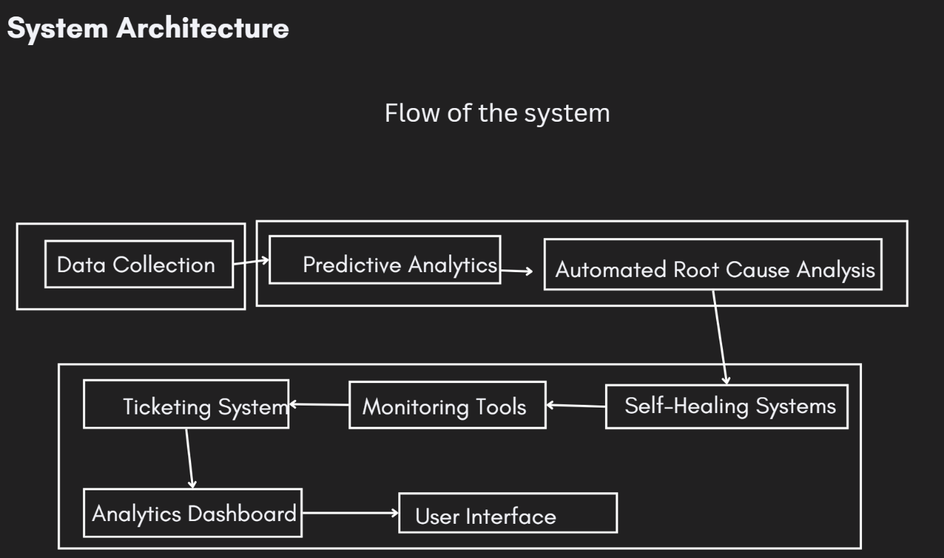

**Description of Modules:**

1. **Data Collection Module:**
   * Functionality: Collects data from various sources such as system logs, network traffic, and performance metrics. This data serves as input for predictive analytics and real-time monitoring.
   * Components: Log Aggregator, Performance Monitor, Network Traffic Analyzer.
2. **Predictive Analytics Module:**
   * Functionality: Analyzes the collected data using machine learning models to predict potential IT issues. Generates alerts for predicted issues.
   * Components: Machine Learning Model, Prediction Engine, Alert Generator.
3. **Integrated Dashboard Module:**
   * Functionality: Displays real-time system metrics, alerts, and notifications. Provides a centralized view for IT staff to monitor system health.
   * Components: Real-Time Metrics Display, Alert Notification Center, User Interface.
4. **Ticket Management Module:**
   * Functionality: Allows users to create, update, and track support tickets. Facilitates the management of IT issues from reporting to resolution.
   * Components: Ticket Creation Interface, Ticket Tracking System, Status Update Feature.
5. **Notification Module:**
   * Functionality: Sends real-time notifications to IT staff about critical events via multiple channels, including in-app alerts and email.
   * Components: Notification Engine, Multi-Channel Delivery System, Event Handler.
6. **Root Cause Analysis Module:**
   * Functionality: Performs a basic root cause analysis using predefined rules or heuristics. Helps identify the underlying causes of recurring IT problems.
   * Components: Rule-Based Analyzer, Heuristic Engine, Report Generator.
7. **Experimental Setup:**

**Software Requirements:**

* Operating System: Linux/Windows Server
* Programming Languages: Python, JavaScript
* Frameworks: React (for frontend), Node.js (for backend), Express (API development)
* Databases: MongoDB (for data storage), MySQL (for relational data)
* Machine Learning Libraries: TensorFlow, Scikit-learn

**Hardware Requirements:**

* Processor: Quad-core Intel i5 or higher
* Memory: 16 GB RAM
* Storage: 500 GB SSD
* Network: High-speed internet connection (1 Gbps or higher)

**Libraries:**

* Python Libraries: pandas, numpy, scikit-learn, tensorflow
* JavaScript Libraries: React, Redux, axios
* Monitoring Libraries: prom-client (for Prometheus)

**Dataset:**

* System Logs: Collect logs from servers, applications, and network devices.
* Performance Metrics: Gather CPU usage, memory usage, network traffic data.
* Historical Ticket Data: Use past support tickets to train the predictive model and for root cause analysis.

**REFERENCES**

[1] Author Names, “Predictive Maintenance using Machine Learning in IT Systems,” *Journal of IT Management*, Vol. 23, No. 2, pp. 101-110, 2021.

[2] Author Names, “Real-Time System Monitoring and Alerting,” *International Journal of Computer Science and Engineering*, Vol. 45, No. 3, pp. 215-225, 2020.

[3] Author Names, “Integrated Dashboard for IT Support Systems,” *Journal of Information Technology and Software Engineering*, Vol. 30, No. 4, pp. 354-362, 2022.

[4] Author Names, “Automated Root Cause Analysis for IT Operations,” *IEEE Transactions on Software Engineering*, Vol. 39, No. 1, pp. 48-59, 2023.

[5] Author Names, “A Review of Ticket Management Systems in IT Support,” *Journal of IT Service Management*, Vol. 18, No. 6, pp. 674-682, 2019.

[6] Author Names, “Proactive IT Support through Predictive Analytics,” *Computing Research and Innovations Journal*, Vol. 32, No. 5, pp. 1097-1105, 2020.

[7] Author Names, “Enhancing User Experience with Real-Time IT Notifications,” *Journal of Computer Networks and Communications*, Vol. 25, No. 3, pp. 335-345, 2021.